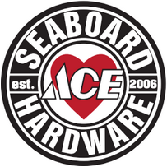
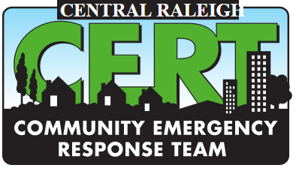

April 6, 2018

To: Manager, Pet Supplies Plus
From: Central Raleigh CERT
Kim Gazella, 919.602.6092, kgazella@gmail.com
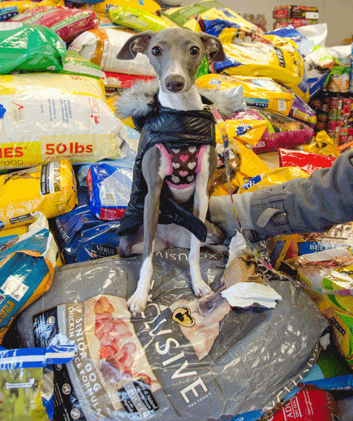
Re: Information on Pet Disaster Planning
Central Raleigh CERT is a volunteer group that has been trained by FEMA to serve as citizen responders in the case of natural or manmade disaster. We work hard to educate the public about emergency preparedness and the importance of planning ahead.
June is National Pet Preparedness Month. We would like to have a table at your store on a Saturday or Sunday in June so we can introduce ourselves to pet owners and provide information about how to prepare their pets for emergencies. We would provide the attached brochure, along with other brochures and information about how to build a home disaster kit. We also would display items commonly found in a home disaster kit.
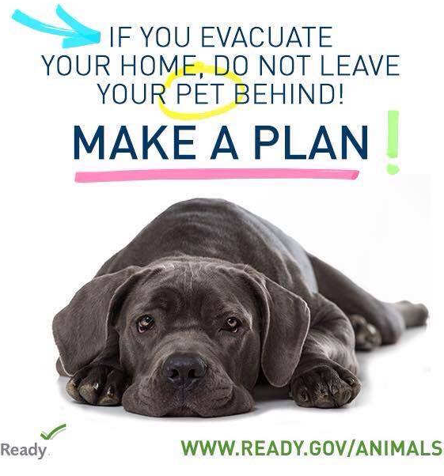
If you are planning another event likely to draw people to your store (perhaps an adoption activity), maybe we could have a table off to the side that day.
We will spread the word through social media and neighborhood list serves. We can make a poster to display in your store ahead of time, and could also provide small bookmark-sized handouts for you to give customers a few weeks ahead to help publicize it.
We hope you will consider letting us partner with you during June for this important public education effort. Thank you!
