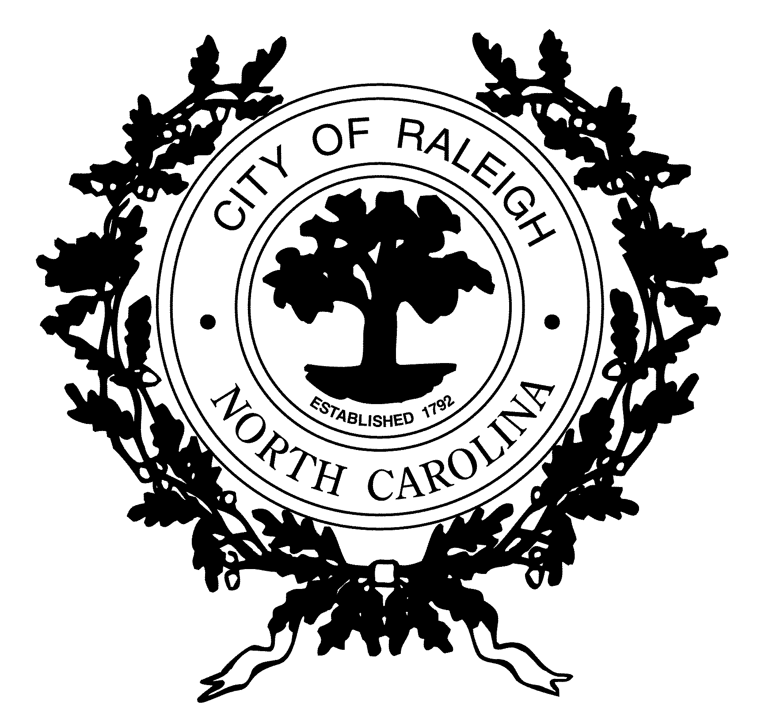

TO: All Raleigh Residents

FROM: Mayor and City Council

The search for a new City Manager has started and we are asking for your input.
The City Manager position is responsible for and accountable to the City Council for managing and leading
the day-to-day operations and services provided by our municipal government to residents and visitors throughout the City of Raleigh. It is a very complex job and it is important that we select an individual who has the knowledge, skills, abilities and experience to ensure we continue to meet the challenges of today while planning and preparing for the future challenges and changes we will face as the City continues to grow.

We invite and encourage your input as we move forward in the recruiting and selection process for this very important role. Your comments and suggestions can be provided in writing or online, whichever you prefer.

Please complete this survey and return to the address listed at the bottom,
NO LATER THAN 5:00 p.m. on WEDNESDAY, JUNE 19

Receiving your response by the closing date will allow us to ensure that your input can be carefully considered in the selection of the next City Manager.

The City’s Human Resources Department will collect the completed surveys. Staff will compile the responses and provide a summary of responses for consideration by the City Council.

Thank you in advance for taking time to provide your input.

- What specific qualifications will the next Raleigh City Manager need most to be successful?

- What are the most important challenges facing the City of Raleigh now and in the years ahead?

- If you could ask the City Manager candidates two questions, what are they?

Thank you for your input. Respond by mail to:
City of Raleigh – Human Resources Director (CM)
PO Box 590
Raleigh, NC 27602-0590
If you prefer, you may complete the survey online at
www.raleighnc.gov

